IT’S YOUR CALLING
BOOKING FORM
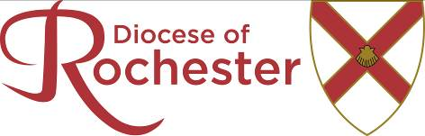

I wish to attend It’s Your Calling at …………………………………. On ….……………..

TITLE …….…… SURNAME (BLOCK CAPITALS) …….…………………….…………….

CHRISTIAN NAME (BLOCK CAPITALS) ………….............………………………………….

ADDRESS .................................................................…………………………….…………

………………………………………………………………………………………....................

POST CODE …............................. TEL NO. ...…..................……………….…..……...

DATE OF BIRTH .……………..…………

E-MAIL ADDRESS ……………………………..…….……….….

How would you describe your ethnic origin?
- African | - Asian
- European (UK) | - European (Other)
- Afro-caribbean | - Chinese
- Other (Please specify)

Do you have any special needs, i.e. access, hearing, sight YES/NO
If yes, please specify:

NOTE: The above information will be held in the Diocesan Office for use by designated people as required by the discernment process. You have the right to change, withdraw consent to use and request deletion of your data as described in the Diocesan General Privacy Notice which can be found on the Diocesan website at https://www.rochester.anglican.org/privacy-notice.php. The information will be destroyed unless required for legal or other legitimate reasons should you cease to be part of this process.

Applicant’s Signature ............................................……… Date ..............………..……

Full name of the church you attend ……................................………………………….

JOINING INSTRUCTIONS WILL BE SENT APPROXIMATELY ONE WEEK BEFORE THE EVENT

TO THE INCUMBENT

Please indicate any areas of calling you have discussed with the applicant or add any other comments that may be helpful in future discussions. These will help with the placing of the applicant with the correct Vocation Advisor following the It’s Your Calling event.

Please add your signature to indicate that you have discussed the applicants calling with them and that you are in support of this application:

Name: …………………………………………Signature: ………………..…………………..

Please return to: The DDOV Administrator, Diocesan Office, St. Nicholas’ Church, Rochester, ME1 1SL or email to vocations@rochester.anglican.org at least one week before the event.

