Baptism Resources

for preparation and beyond

August 2022

.
Preparation for families and children

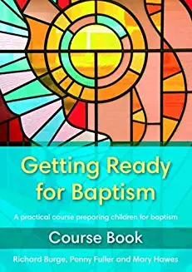
Getting Ready for Baptism: Richard Burge Penny Fuller and Mary Hawes
Getting Ready for Baptism recognises that baptism can take place at any age and stage of life. Its aim is to deepen understanding of the biblical background to baptism for all involved and to explore what it means to be a child of God. With the emphasis on facilitating rather than a teacher-led approach, the material seeks to encourage all those involved in the sacrament, whether they are the candidate, the parent, godparent, friend, extended family member or member of the church community.
Part 1 focuses on baptism as a ministry. It explores the relationship between the candidate, parents and godparents, examines the place of discipleship for those taking part, considers the implications of baptism for the whole worshipping community, and places the emphasis on baptism being a step to belonging as well as a statement of belief.
Part 2 offers three practical sessions: Come to the party!, Enjoy the party! and Party on! A task-based activity book is available separately to help the child make a personal record of his or her baptism journey.
Although very popular this book is only currently available from Amazon or second hand and there are no workbooks for candidates. We have a copy if you would like to see it.

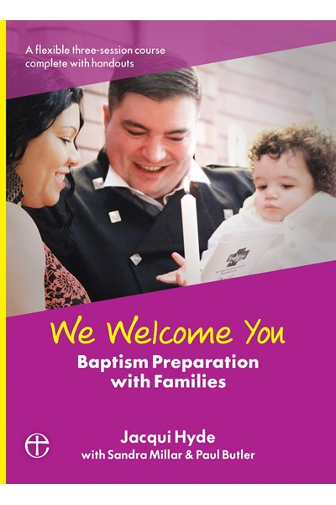
We Welcome You is a ready-made, three-part course to help prepare parents and godparents bringing children for baptism.
Informal and participative, with the emphasis on welcome, the sessions cover:
- Getting ready - The big day itself! - What Christening means for the rest of life
It uses a wide range of learning styles and resources, from film clips, creative storytelling, reflection and discussion, to craft and icebreaker activities. It also offers resources to help the church family understand its key role in baptism and offer the best welcome possible.
Designed to be used either in small groups or with one family at a time, We Welcome You is suitable for large and small churches alike.
We have a copy of this book.
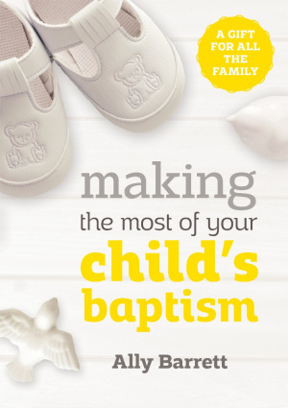
Making the most of your child's baptism.- Ally Barrett
A short, full-colour gift book which explains the baptism service for parents. Aimed at those not familiar with church, this book explains what baptism is and is structured around the service itself. It includes questions to think about and follow-up activities for parents and children. It can also be used for baptsim preparation.

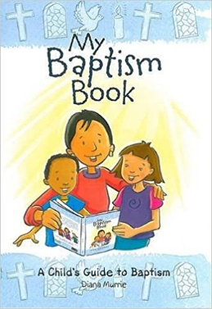

My Baptism Book
My Baptism Book aims to help children understand one of the most important days of a child's life. It is a beautiful personal reminder of this special day and one that a child can return to again and again. It can be used by adults and children together, or in more formal baptism preparation and includes a number of inspiring ideas on ways to use the material creatively. This is an ideal gift for children aged 3+.

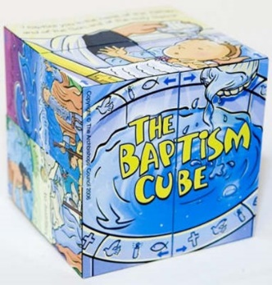
Baptism Cube
The cube is aimed at children aged 3+, this sturdy, robust cube is a perfect gift for a child about to be baptised or for an older sibling of a baby being baptised. In a fun, interactive way, it helps children to learn about the main features and symbols of the baptism service. The illustrations are matched by those in My Baptism Book.
We have several of these if you would like to borrow them.

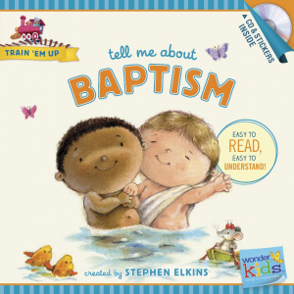
Tell Me About Baptism is a reminder of a special day in a child's life. A friendly train conductor, Mr. Steve, teaches the fundamentals of baptism, what it is, and why followers of Jesus should be baptized. Through bold graphics and interactive songs and stories, Train Em Up makes it easy for parents and teachers to explain biblical concepts like baptism in a way that helps with attention, memorization, and recall while building a solid faith foundation.
Each book in the series includes a CD with sing-along songs and narrated stories with sound effects, and a sticker sheet.

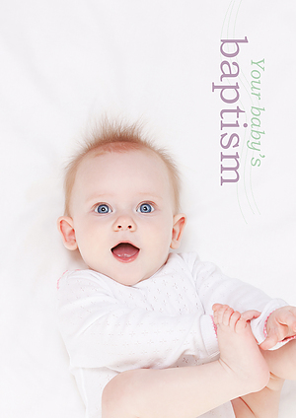
Your Baby's Baptism offers a complete guide for families preparing for their baby's baptism. It answers the common questions asked by all wishing to have their child baptised in an Anglican church and gives an overview of the baptism service, helping the family to understand and fully participate on the special day.

Godly Play
Baptism presentation with children ages 4 and up and their families. It works really well with lots of room for questions.
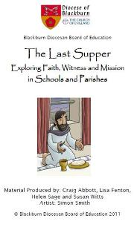
The Last Supper
Is a resource written by the Diocese of Blackburn to help prepare children for Baptism. The material covers several aspects of faith so please email Sarah Earnshaw (Sarah.Earnshaw@Blackburn.Anglican.Org) as she can send just want you need.
Last Supper CD ROM – Blackburn Diocesan Board of Education (bdeducation.org.uk)

Helping families engage with baptism and continuing that relationship
The Church of England support hub has a very helpful document to help you consider how baptism could work best in your church.

https://churchsupporthub.org/wp-content/uploads/2014/11/Making-families-welcome-in-template.pdf

- Invite the families to a couple of services in advance of the Baptism – they will be more familiar with your style and it will give an opportunity for others to engage and make friends with them. Encourage those that have been part of the preparation to greet and sit with them during these services.
- Help families know what to expect – a visual service order for children who will be attending will help. If there is a ‘Family Seating Area’ explain how it works. Reassure them that noise from children is ok. They will be unsure how the church will react!
- Explain to families before the service if there will be activities their children will be welcome to join and that they can accompany them (check how this will work with your PSO). During the service make it clear that all children are welcome to take part in activities.
- Ask those involved in the baptism preparation to give the Baptismal candle during the service. Give a good children’s bible too (ask us for ideas). One church is making individual bags for each candidate with a book and other small gifts.
- A child’s baptism is an opportunity for follow up. Send cards and invite them to church on the anniversary. Include what is currently happening in church life especially toddler groups, preschools and family events.

Helping Parents with their Child’s Faith
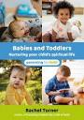
Parents bring their child for baptism for many reasons – some from a deeply held personal faith and others because it seems like a ‘good’ thing to do for their child and everything in between. Whatever their reasons they see this as good for their child so offering a book that will help them accompany their child on this faith journey would be a good start.
Babies & Toddlers Nurturing you child’s spiritual life is a well written book accessible for wherever the parents are on their faith journey. We have a copy of this in the office.

Child’s Bible
Another great way to help families meet God is to gift them with an appropriate Bible.
Look at our list of Bibles, we also have some to look at, to help you make a decision as to the most suitable.

