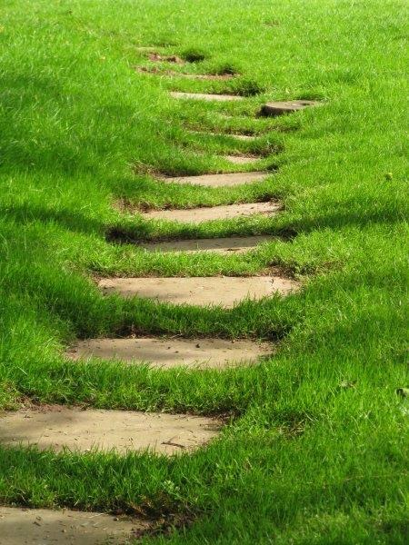

Where?

65 Maidstone Road, Chatham

ME4 6DP

Christ Church Chislehurst 40 Lubbock Road, Chislehurst  BR7 5JJ

One line (zoom)

For more info about the next Closer course contact: Rev Canon Susanne Carlsson (Adviser for Spirituality in Rochester Diocese)

[susannecarlssons@hotmail.co.uk](mailto:susannecarlssons@hotmail.co.uk)

07795167603

Suggested Donation? 10-15 per session

Closer…

**Exploring Christian Spirituality**

Closer…

Who is this who calls me close?

Love calls love: *meet me…*

Closer…

**Exploring Christian Spirituality**

Saturdays 10.30

Session 1 What is Prayer?

Session 2 Images of God and Self

Session 3 Different Ways of Praying

Session 4 Different Ways of Praying

Session 5 Discernment and Decision Making

Session 6 Different Spiritualities

Session 7 Deepening and Review

You need to attend all sessions and you will be encouraged to use what you learnt in between sessions.

Closer…

is a one year experiential course in Christian Spirituality.

The course will offer both exploration and experience of the depth of Christian Spirituality.

The participants will:

* Explore and develop their own relationship with God.
* Try new ways of praying.
* Learn about different Christian Spiritualities.
* Explore discernment and decision making.