Preparation and teaching on Communion for Children.

August 2022

It is important for children and young people to understand what Communion is and why it is important.
Find an opportunity in the year to do some age-specific teaching to help them learn and ask questions.
Children’s thoughts on Communion in a video: https://www.youtube.com/watch?v=pKXxXOHexTw
Pinterest has these pages for resources
https://www.pinterest.co.uk/revmaryhawes/holy-communion-resources/
https://www.pinterest.co.uk/margaret_pritch/communion/
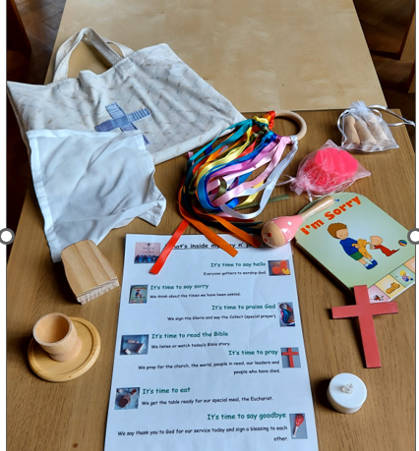
Flame Creative also has ideas to explore communion with children: http://flamecreativekids.blogspot.com/p/exploring-holy-communion.html

To help children engage with communion on a Sunday consider a ‘pew-bag’ with suitable resources. Here is a good example. Ask the CYP team for more details.

These are books to help you prepare children to receive Communion before confirmation. We have many of these in the Diocesan Office so please ask to have a look before making a purchase.

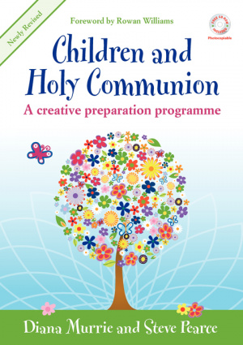
In the first half of this book Diana Murrie and Steve Pearce carefully and thoughtfully set out the background to the huge strides taken in this important area. They present many convincing reasons for the admission of children to Holy Communion, based on the actual experiences of churches, citing many stories of benefits to children and congregations.
The second section has practical, tested material that has proved an invaluable aid for use with children as they prepare to take this important step in their Christian life.
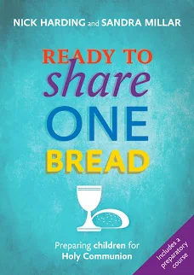
This is a guide for churches considering the admission of children to Holy Communion providing all a church would need to consider and help along the way to admitting children.
This includes resources for exploring the issue with a whole congregation, case studies from real-life churches, a preparation course, an admission liturgy and advice on including and involving children in Eucharistic worship. The book also includes theological reflection on children and the Eucharist from Michael Perham and considers the impact of receiving Holy Communion on children's discipleship.
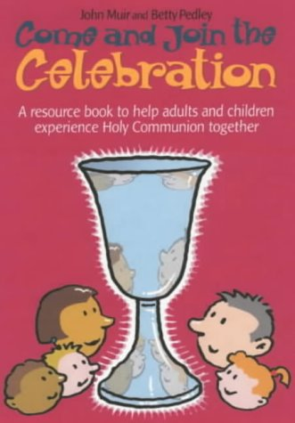
This photocopiable resource contains guidance on how to help children understand the liturgy and structure of Holy Communion; activities for use in church with 2-6 year olds; resource sheets for 7-11 year olds; and ideas for additional uses including Communion before confirmation, workshops and school Eucharists. The book aims to help adults share worship with children, thus enabling everyone to participate more fully.
This is currently only available secondhand.
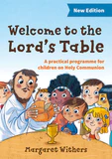
This is aimed primarily at church and children’s ministers, parents and teachers to help children aged 7 - 9 to participate fully in eucharistic worship, it explores the background to the question of preparing young children for Holy Communion, give guidance on preparing the congregation, training leaders and involving the family, and includes a guide to using the programme. The programme itself comprises eleven flexible teaching units and is designed to last approximately three months overall, with the children receiving Holy Communion towards the end of the programme. There is an activity book available for each participant.

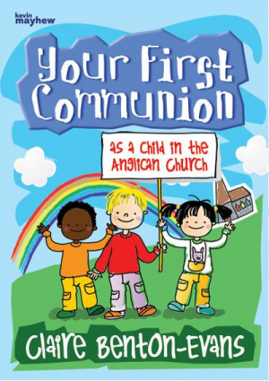

A child's first Communion is a very special occasion. This clear and colourful book will help children to learn all about Holy Communion and what it will mean for them and the Church. It explains what happens in a Communion service and answers a variety of questions that children may have leading up to this important event.
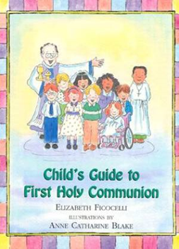
Written in the spirit of the best selling Child's Guide to the Mass, this is a charming yet informative picture book aimed at children who are preparing to receive this important sacrament for the first time. Written in an engaging, easy-to-read manner, this book follows Justin as he attends Mass to receive his First Holy Communion.
Throughout the book, there are interactive questions ("What are you thankful for?") designed to encourage discussion between the child and parent or teacher.

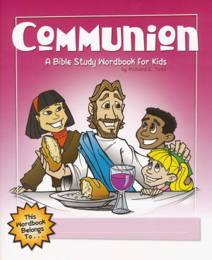
Part of a series of Wordbooks to help kids grow in their faith. Perfect for use in Sunday School, Bible clubs, midweek programs, children's church, or at home with a parent. These biblically based books have Scripture, activities and ideas for personal application. Students will enjoy mazes, word searches, colouring pages, cryptograms, quizzes, certificates and much more!
This is an ideal aid for children in helping them to understand the theological complexity of communion. It explains the origin of communion in a simple way so children understand both the significance and the context under which it is performed. The book illustrates the history of communion, how it is done and why.
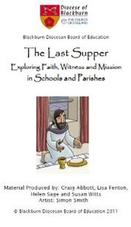
The Last Supper is a resource written by the Diocese of Blackburn to help prepare children for Holy Communion. The material covers several aspects of faith so please email Sarah Earnshaw (Sarah.Earnshaw@Blackburn.Anglican.Org) as she can send just want you need.
Last Supper CD ROM – Blackburn Diocesan Board of Education (bdeducation.org.uk)

Godly Play is another way of preparing children to receive Holy Communion.
There are 5 sessions where stories are shared as part of the preparation. Baptism, Exodus, Jesus the Good Shepherd, Faces of Easter and Holy Communion. This has been planned by Rachel Archer – please contact her or the CYP Team for details.

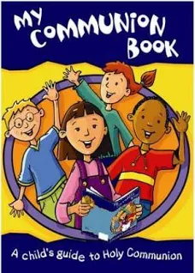
This book is aimed at 4-8s to help them gain a better understanding of Holy Communion
Designed to support the service in Common Worship this fully-revised edition of "My Communion Book" helps children gain a better understanding of Holy Communion. It can be used initially as a sharing book, adult and child reading together, but children may use it at times on their own. Taking the child through the service, the book explains key words and asks questions that relate directly to the child, helping them to engage with the service of Holy Communion in a fun, interesting and meaningful way.
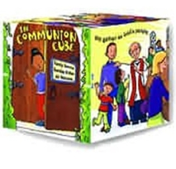

Children and communion services aren't always the easiest of combinations! This is a full-colour cube esigned for children between 4 and 8 years-old, it can be used during church as a fun way of taking children through the service.

Going for Growth website has a page of resources including the regulations and liturgy
http://www.going4growth.com/growth_in_faith_and_worship/sacraments/holy_communion
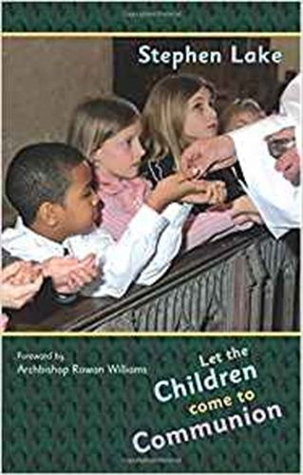
Let the Children Come to Communion: encourages the admission of baptized children to communion; summarizes in one place relevant practice, information and theology; shares the experience of those who have already taken this step; aims to help move the debate on, encouraging the Church into full participation. The author's fervent hope is to stir the Church into action on an important issue and to stimulate decision-making about introducing and developing this ministry with children. There are extended interviews with leading practitioners including: David Stancliffe, Stephen Venner, Diana Murrie, Margaret Withers and Mark Russell. Stephen Lake is Sub Dean and Canon Residentiary of St. Albans Cathedral.

