Preparing Young People for Confirmation

Date August 2022

Here are some books which could be used to prepare young people for confirmation. Some churches choose to use Youth Alpha or Youth Emmaus instead. The sources underneath are simply places we have found them available.
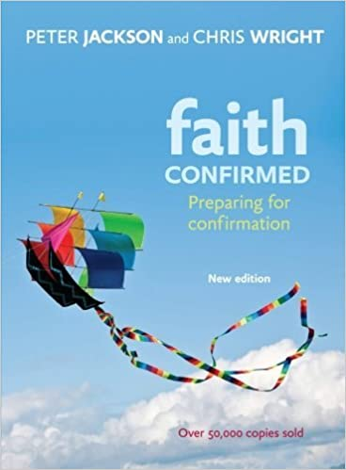
Faith Confirmed is an introduction to what Anglican Christians believe. It is written for those preparing for confirmation in the Anglican Church and for all those who want to know more about the essentials of the Christian faith.
Amazon/ Eden

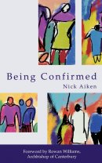
Being Confirmed is a practical guide to the basics of Christianity which is ideal for young people preparing for confirmation. Aiken explains clearly and effectively what it means to be a follower of Christ.

Eden

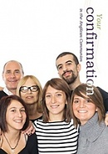
Your Confirmation was revised and refreshed for 2016. It invites young people to look at where they are in their life, and to consider this important step towards growing in faith. Written with adult confirmands in mind, as well as children and young people; Steve Givens provides a lucid, entertaining and accessible guide that clearly deals with the questions that confirmation candidates want answered.

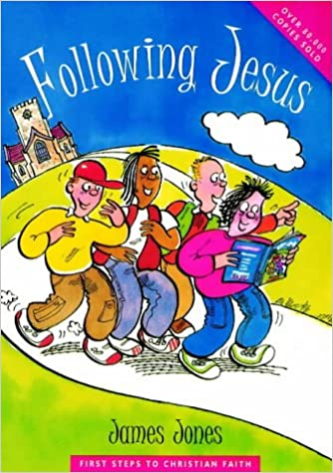
Eden

Inviting the reader to start out on the most important journey in life, this book covers 31 basic steps in Christian teaching, including: is there a God?; prayer; who is Jesus?; belonging to the Church; what is faith?; the Bible; Christian discipleship; Holy Communion; Christian witness; the resurrection; Christian worship; the Holy Spirit. This text has been widely used in Confirmation training, evangelism and youth groups. Its accessible format is designed to encourage the habit of regular Bible reading and prayer.
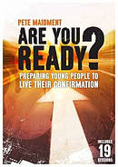
Are You Ready is a practical resource to help you prepare your young people for confirmation.
Presented in two easy to manage sections, the first part helps you focus on the promises asked of young people at the confirmation service.
Supporting your confirmation preparation and pastoring of young people, this prequel to the confirmation gift book, Living your Confirmation contains 19 ready-to-use sessions to help you interact constructively with young people who are preparing for confirmation including prayer, Holy Communion, going to church and social action.
The first part of the book focuses on the promises made in the confirmation service, the second part includes sessions on sex, alcohol, image, exams, science, pornography and suffering.
The introduction to Are You Ready considers the purpose of confirmation and its role in a young person's faith journey. The book also includes a full programme for a pre-confirmation retreat and a liturgy for the enrolment of confirmands.
Eden

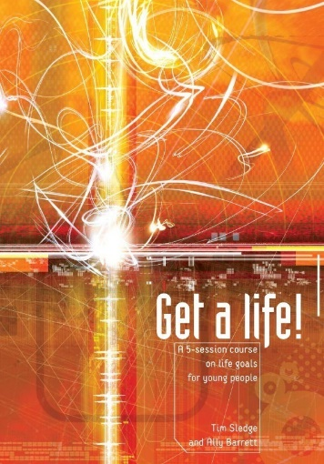
Get A Life is a follow-on from the popular Youth Emmaus books is an exciting new course for young people. Get a Life! approaches some of the big questions that 13-18 year-olds face in their secondary school years, including issues of vocation, calling, gifts, passions and the big question that many young people dread being asked: 'What do you want to do with your life?'. Written in an accessible manner, the five sessions draw on contemporary culture and include interactive material to explore the issues and themes of calling, gifts and service.
Ideal for 13-18 year olds who are making big decisions about the future, as a pre- or post-confirmation course, as a Lent course, or as an after school series.

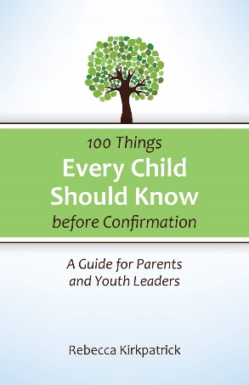
100 Things Every Child Should Know is an overview of one hundred essential topics that all children growing up in the church should learn about, including key Bible stories, church history, the sacraments and creeds, world religions, and more. Each entry includes a brief summary, a suggestion for how educators and parents can explore this item with their children, and ideas for integrating the topic into the child’s overall Christian education. This practical resource helps children think critically about Christian faith as they begin their confirmation studies, providing the vocabulary and understanding needed to articulate their own theology.

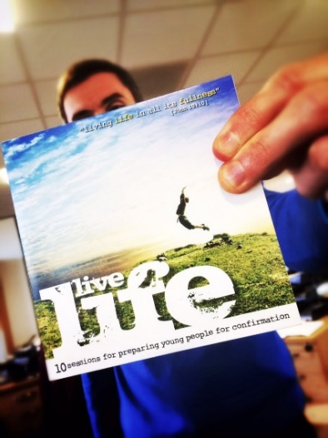
Live Life is fresh and flexible resource that introduces young people to the Christian faith and prepares them for Confirmation within the Anglican Church.
Through ten interactive and engaging sessions ‘Live Life’ aims to create safe spaces for young people to discuss, question and deepen their understanding of God. Each session follows a familiar and flexible structure with practical guidance for enthusiastic volunteers through to experienced youth workers and church leaders.
Written by Dan Jones and Tony Cook for Bristol Diocese. Downloadable.
https://www.bristol.anglican.org/churchlife/resourcesforparishes/childrenyoungpeopleministry/live-life-resource/
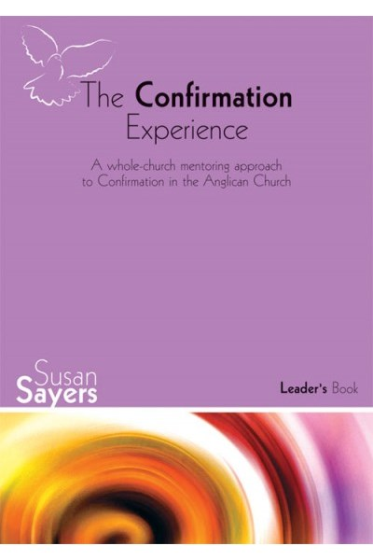
The Confirmation Experience aims to celebrate Confirmation in a way that grows a healthy community of Christians. Using the image of a journey, there are twelve very varied events rather than a course of study, in which all candidates take part together, along with other members of the church community.
There is a leaders book as well as books for 11-14’s and adults. From Church House Bookshop.

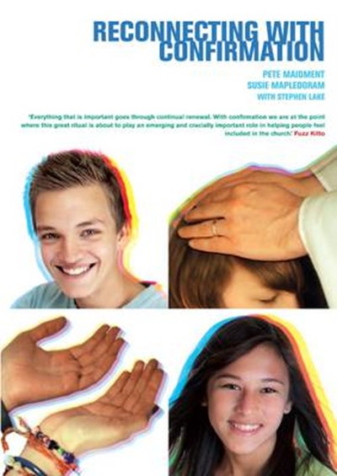
Reconnecting with Confirmation is aimed to equip clergy, lay leaders, youth workers and PCCs with a deeper understanding of the origins and theology of confirmation, and of youth culture with its needs for rites of passage that acknowledge within young people an adult faith and an adult position within their church. It will enable churches to put confirmation at the heart of youth discipleship. It includes:
- A clear and comprehensive history of confirmation and its place today.
- A holistic view of adolescence and faith/spiritual development that can inform how we approach and facilitate confirmation.
- A practical guide to creating the best confirmation experience for young people - from preparation, to the rite itself and beyond.
Church House Publishing

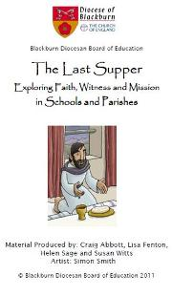
The Last Supper
Is a resource written by the Diocese of Blackburn to help prepare children for Confirmation. The material covers several aspects of faith so please email Sarah Earnshaw (Sarah.Earnshaw@Blackburn.Anglican.Org) as she can send just want you need.
Last Supper CD ROM – Blackburn Diocesan Board of Education (bdeducation.org.uk)

