St Augustine Anywhere

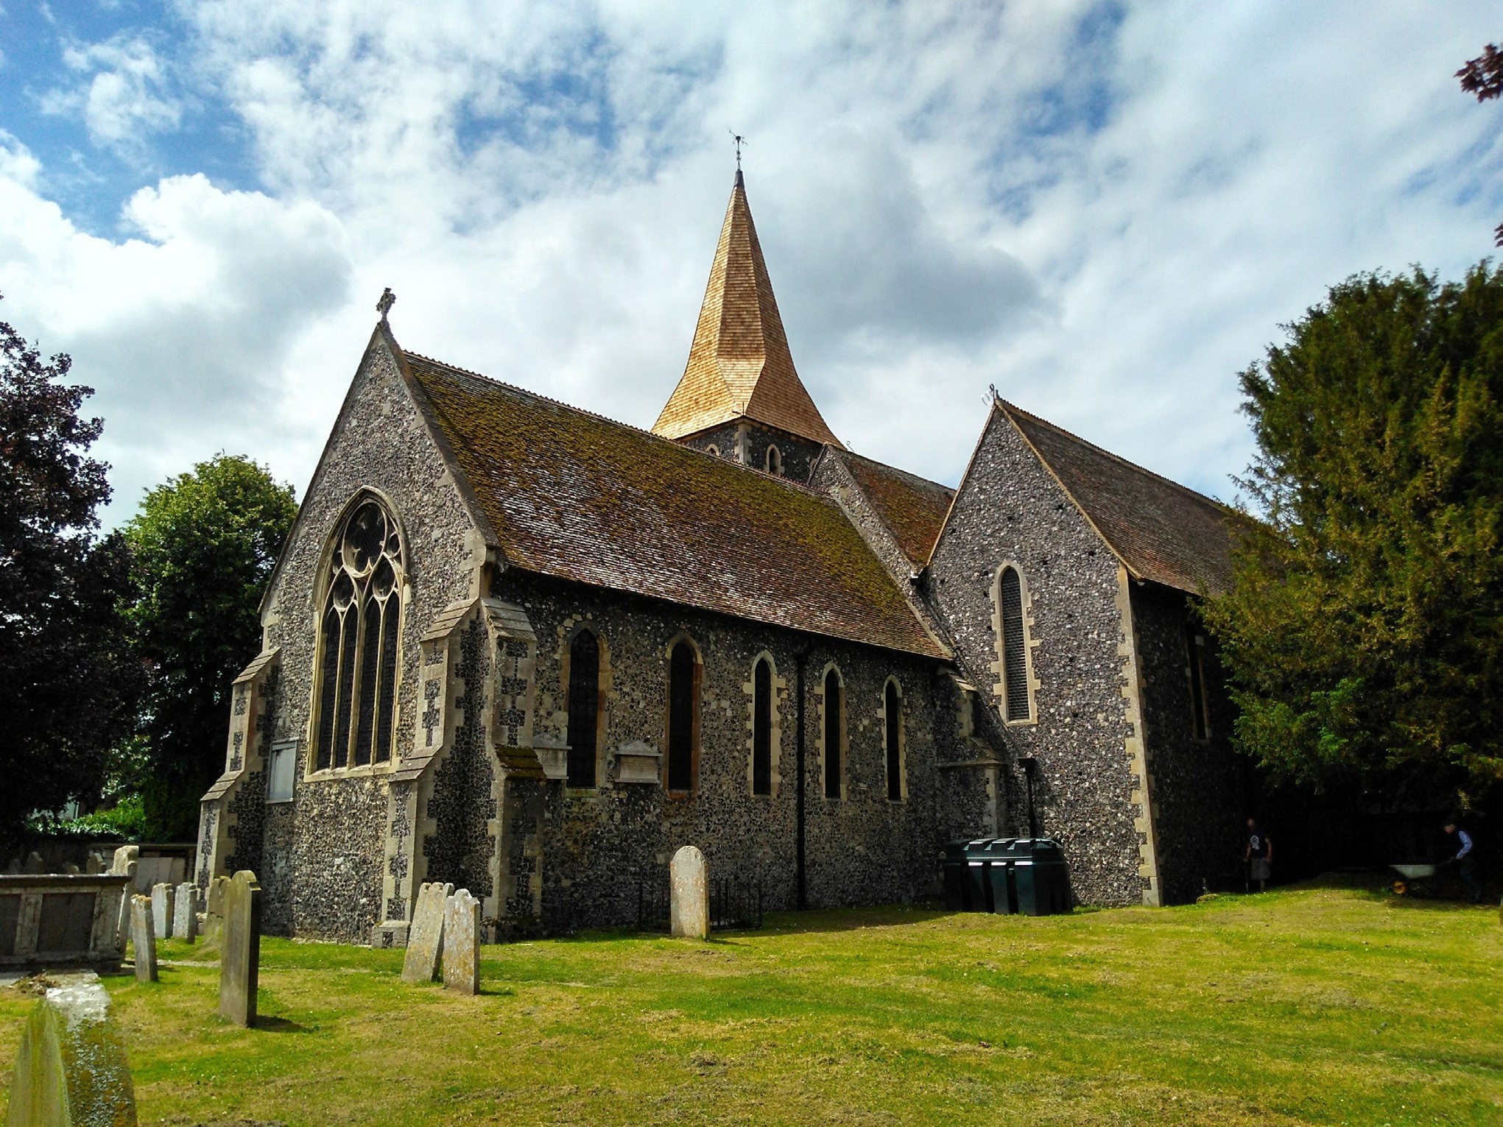
Generosity Sunday
Sunday xxx, 10.00am at St Augustine’s Church
The service will include a presentation on the future resourcing of our Church.
All Welcome

