A message to the people of xxxxx

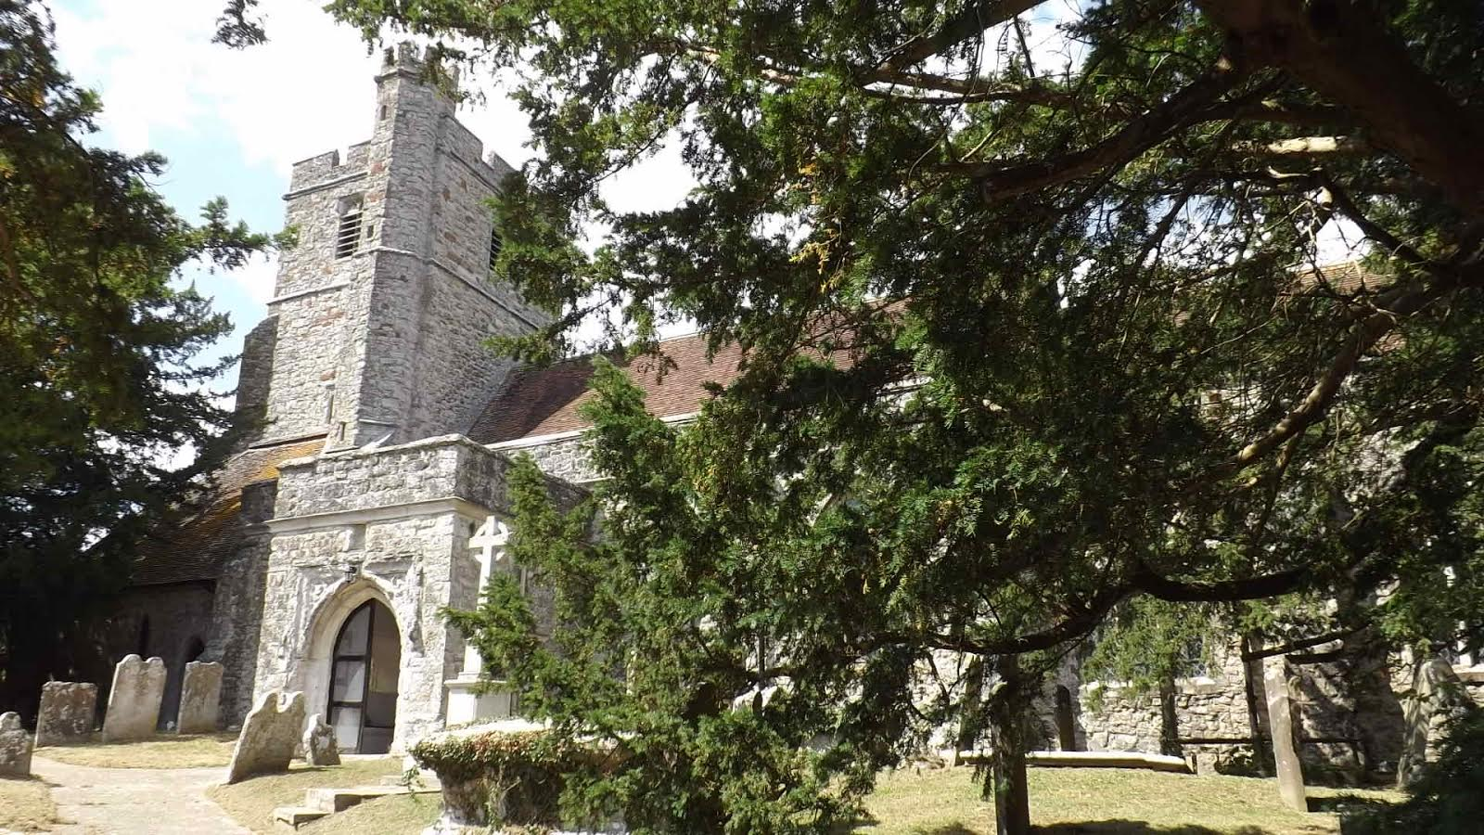

It is said that if you want to know an English village, look at its church. Have you ever looked at your beautiful listed building? Have you been inside recently?
The upkeep of our church and indeed all of our village churches – both the fabric and the ministry – is entirely the responsibility of our small congregations. We receive no funding whatsoever from either the central Church of England or government, and if we want our church to be there for future generations we have to continue to bear that responsibility.
Some of us com to St xxx’s out of faith, others out of love of an ancient building, but we are all determined to make sure our church is open for al when needed. St xxx has been here, in the centre of our village for over xxx years. It has watched as the village has been through plague, civil war and two World Wars. It has been a constant presence in time of trouble and sadness, times of celebration and gladness and for funerals, christenings and weddings.
We now need to ask whether we want our village church to continue for the future, or whether we will be the link which fails in a chain which has lasted for almost a millennium.
We are asking you now to help by making a financial contribution to the upkeep of our building, either as a one-off donation, or by setting up a standing order/direct debit [with link to PGS website, if applicable]. That contribution will help to ensure that our wonderful church will be there for our children and grandchildren in years to come.
With kind regards

Rector/Churchwarden

