Children and Young People Fund

Criteria Ticklist for Applicants

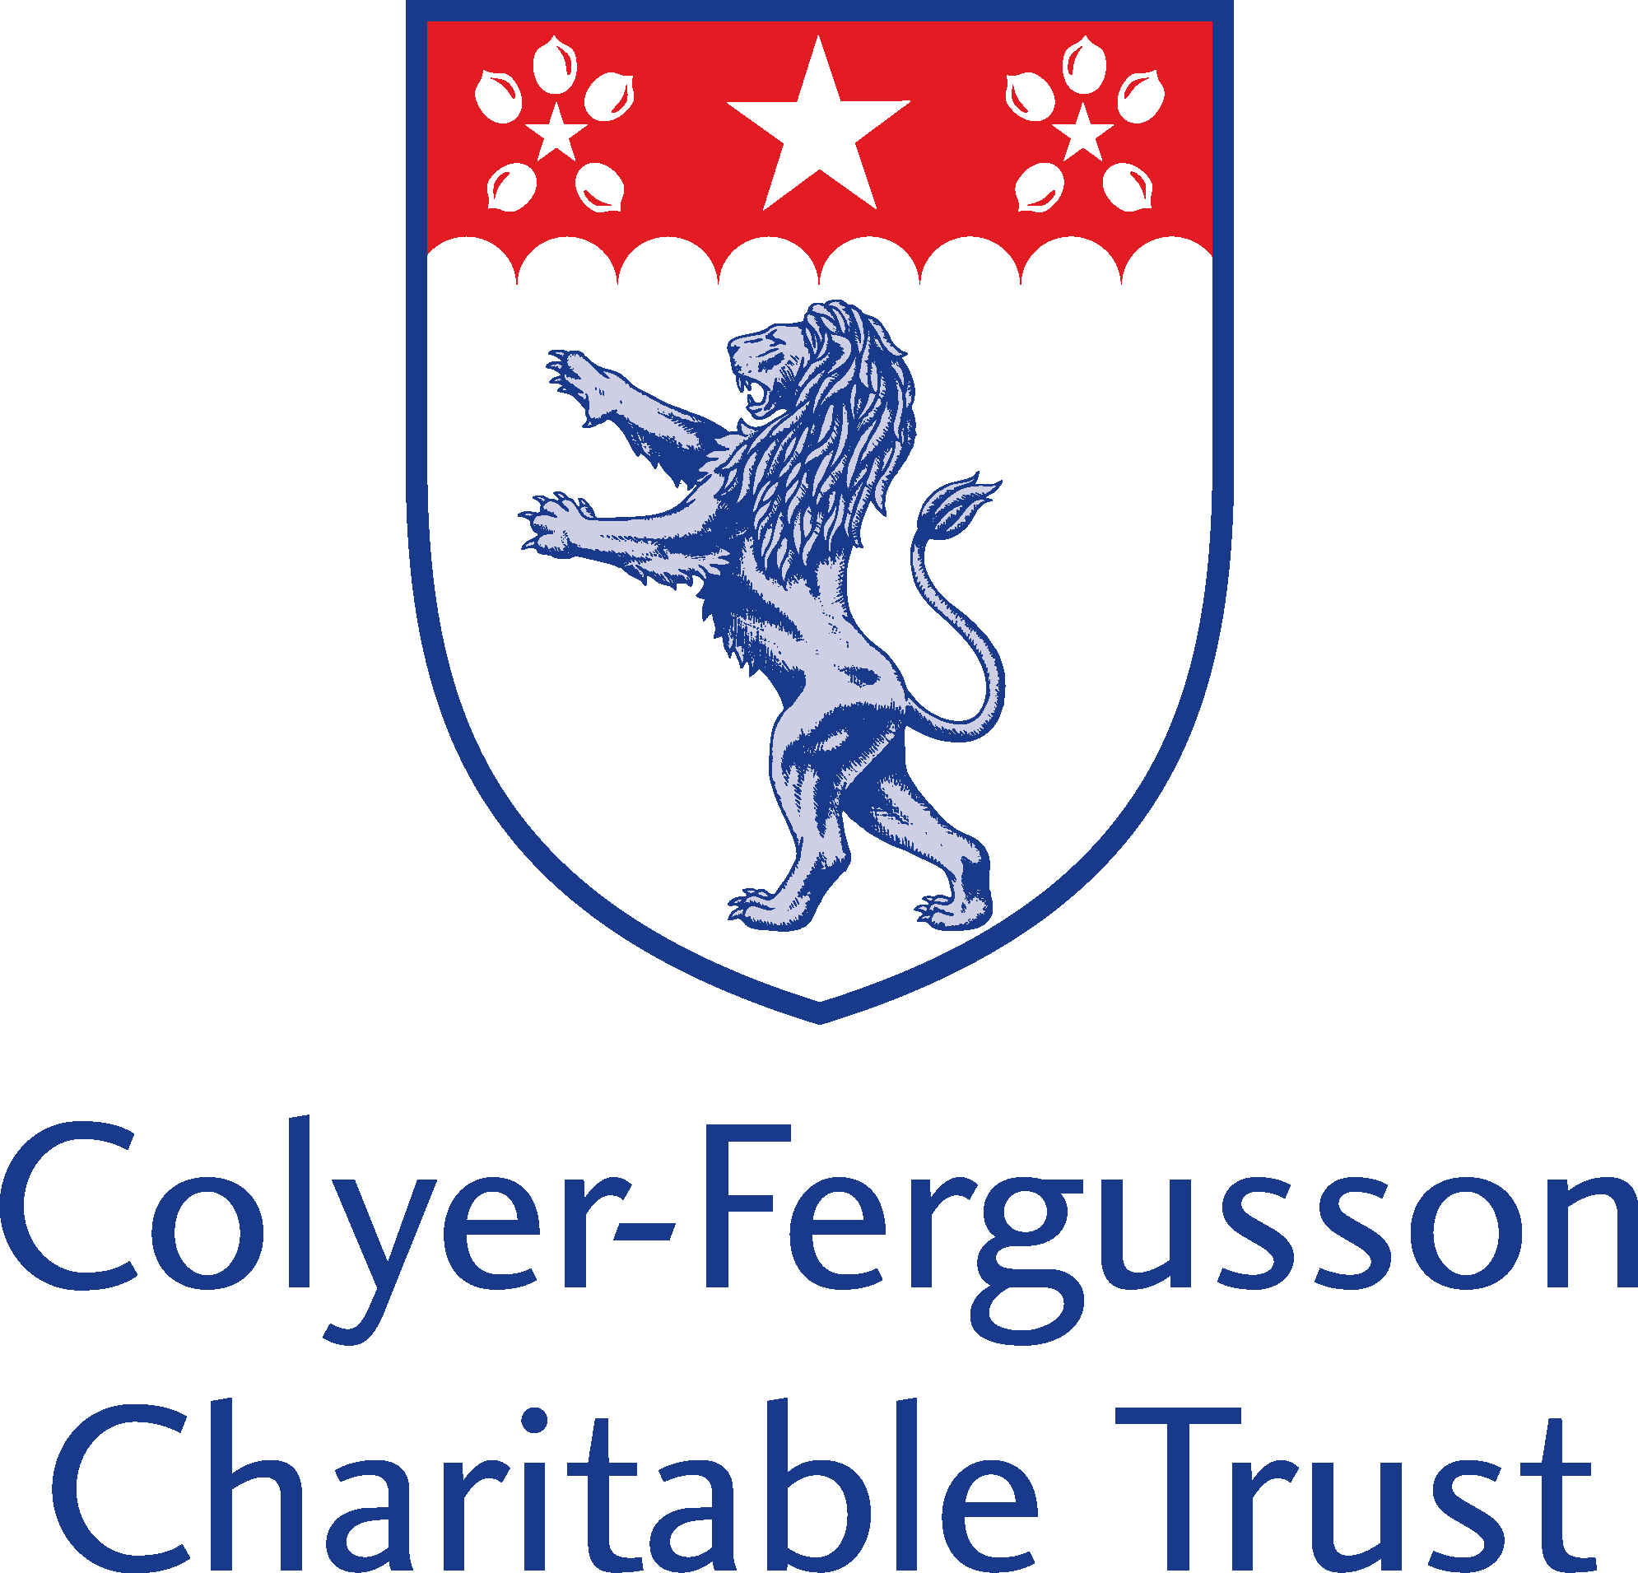
Cheryl Trice, Laura Webster, Sarah Cabella. Diocese Children and Young People Team.
Updated July 2021. January 2018
The purpose of this Criteria Tick List is to enable you, as applicants, to establish if you are eligible to receive a grant from the CYP Fund in accordance with the criteria and guidelines. To meet the funds criteria, it is necessary to match (YES) to a minimum of 70% of the questions below but a definite match to b, c, d, f, g, k, l, m with strong consideration to the others. Please use this as a guide before beginning to fill in an application form.

This form must be returned with your application form, electronically if possible.

PROJECT NAME : …..………………………………………….…………………..

NAME OF PARISH / CLUSTER : …………………………………………………………….

DEANERY : .…………………………………………………………..

ARCHDEACONRY : .………………………………….………………………..

CRITERIA | YES OR NO
- Is the application from a Church, PCC or Deanery Cluster?

- Is the project / ministry specifically aimed at Children and Young People?

- Specific opportunities / projects to enhance and enrich the lives of LOCAL children and young people;

- A strong evidenced commitment from the applicants to the projects by providing, support, volunteers and an understanding of the community it serves (this will need to be outlined on the application form)

- Combining vision with reality and future developments

- Intentional spiritual discipleship and faith building through the objectives / aims, therefore enabling people to be Christ centred and the complete person Christ intended them to be;

CRITERIA | YES OR NO
- Evidence of the parish(es) consideration of their local communities and the impact / difference that enables the project to grow, enrich and resource the community (5 Called Together priorities)
- Does the project cover and/or include social action, informed education and improving community cohesion?

- Enabling earning or greater earning capability;

- Deal with issues associated with low income – including self-esteem, self-worth, motivation, identity and poor mental health
- Provide environments where relationship, trust and commitment to the local community becomes embedded into the churches ministry and mission;

- Create a culture of change, improving social inclusion and self-belief / worth for all

Please return this document with your application, electronically to-
CYP Fund, c/o Mrs S. Cabella, Diocese of Rochester, St Nicholas Church, Boley Hill, Rochester, Kent. ME1 1SL.
Email: sarah.cabella@rochester.anglican.org

For Office Use Only.

Panel Approved / Not Approved / Approved following further actions

Dated ………………………………………….

Comments :

