After all that work?

The Bishop presents certificates to students at the annual Celebration of Learning. The Certificate gives students permission to exercise a local ministry under the supervision of their incumbent.
You will be able to:
- demonstrate your maturing faith
- communicate your faith engagingly in a variety of ways
- communicate key biblical themes
- use your study of theology and the Bible as a resource for ministry and mission
- contribute to Christian ministry as a reflective practitioner
- talk about Christian faith in a pluralist world
- identify and understand different approaches to theology, biblical studies, ecclesiology and missiology
“We found much good practice in this course, including its integration into diocesan structures for ministerial development, the high quality of its teaching and learning opportunities, the remarkable sense of community amongst a dispersed group of students.”
Church of England Periodic External Review 2016
Is it worth it?

The Bishop’s Certificate costs £400. This can be paid in two instalments. Parishes are asked to offer financial support when cost would prevent a student from joining the programme. Parishes may also offer travelling costs and the cost of books.

What support is there?
Students get support from Learning Advisers and tutors.
They form their own peer group support.
Each student has support from their incumbent and a formational group supporting them in their church
Students are supported by the Programme Manager and Administrator based at the Diocesan Office.

OK how do I apply?
If you have attended an ‘It’s Your Calling Day’ you will be invited to apply for the Bishop’s certificate. You will need to complete the application for and get your incumbent to sign showing their support.

Further information from:
Rev Jane Winter
training@rochester.anglican.org

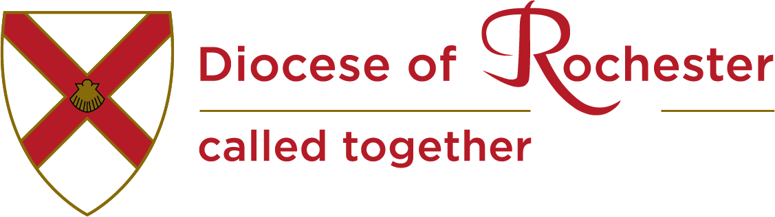

Rochester Diocese
The Bishop’s Certificate

A course in
Christian Ministry

“My incumbent suggested that I start the Bishop’s Certificate. The course is intended to be transformational and that is exactly what was. It was like being a new Christian all over again because it was possible to discuss things openly and honestly, and explore beliefs in a fresh way.”
Former student

Why me?

You are probably reading this leaflet because you are exploring the ministry to which God is calling you or because someone you know is thinking about a call to ministry.

The Bishop’s Certificate in Christian Ministry is a foundation programme open to anyone who wishes to gain knowledge and skills to give a firm foundation to their Christian life and service. It is designed for those wishing to further their understanding of their Christian faith, in the context of discerning a possible call to a local or licensed lay or ordained ministry.

The programme builds on the experience that people bring from putting faith into practice at church, work or in other contexts, and on prior learning about Christian faith.

The programme is written and facilitated by the Formation and Ministry Team of the Diocese of Rochester. It is open to anyone who has attended ‘It’s Your Calling’ and is supported by their incumbent.

So what?

The purpose of the programme is to enable and equip you to:
- develop in your prayer life and spiritual formation
- connect and integrate the study of theology and ministry with pastoral and missional practice
- establish the practice of theological reflection as a means of making sense of ministry and mission and as a tool to help shape action
- undertake structured ministerial experience to acquire and develop a range of skills
- communicate the Christian faith through word and action with imagination and passion
- deepen your understanding of various models of mission and the contexts in which you can be effective
- grow in self-awareness and appreciate diverse expressions of ministry as the outworking of the Christian life
- clarify your vocation and identify your gifting and call to ministry

But how?

Teaching is over five terms at St Benedict’s Centre West Malling Abbey on Tuesday evenings and some Saturdays. There is one residential weekend.

The termly modules cover:
- Mission and Ministry exploring what mission means today
- Bible and Belief an over view of the Bible and the creeds
- Worship and Spirituality introducing different spiritualities and how to lead worship
- God’s word in the world using the bible and doctrine to inform ethical decisions
- Pastoral Ministry and Christian Discipleship developing good practice in age related pastoral care and discipleship formation
A yearlong module: Ministry in Context develops skills in theological reflection

To gain the Certificate students complete:
- six modules and assignments;
- Diocesan safeguarding C0-C2;
- Addressing Bias: how we manage bias in Christian ministry. We explore race, gender, sexuality, aging and disability.

